**VbA Excel**

**Exception is not handled for non whatsapp no .**



1. You have to install these file in computer for using of importing in vba.
2. And find the path of the installation files .
3. For selenium basic C:\Users\nameofthefolder\AppData\Local\SeleniumBasic
4. for selenium wrapper C:\Program Files (x86)\SeleniumWrapper



1. Download chromedriver.exe according to your google chrome version.
2. Copy your chromedriver.exe and replace in both the selenium wrapper and selenium basic file following with the path I shown above .
3. 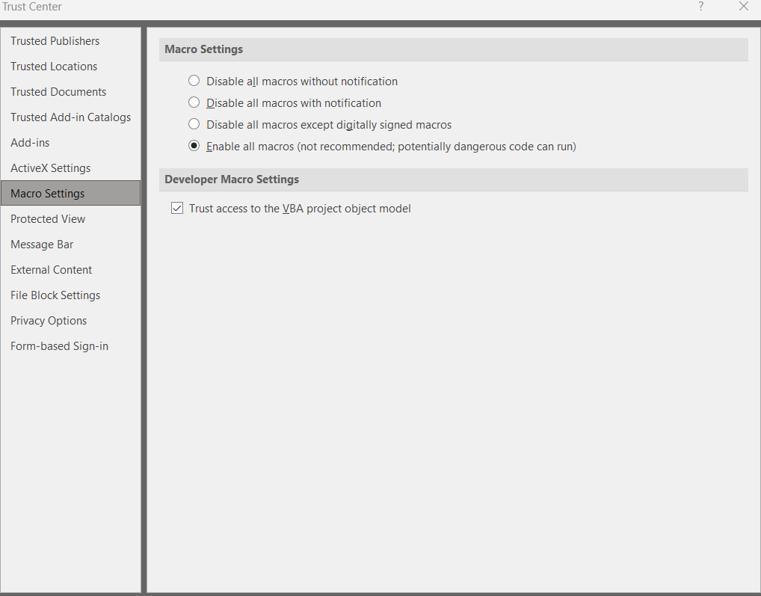
4. Go to excel >option >trust centre >macro settings > click on the checkbox trust access to the vba project object model and click on the enable all macros
5. 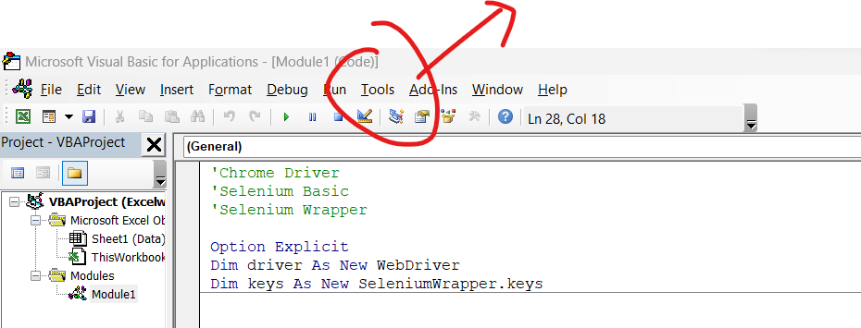
6. Then click on references
7. 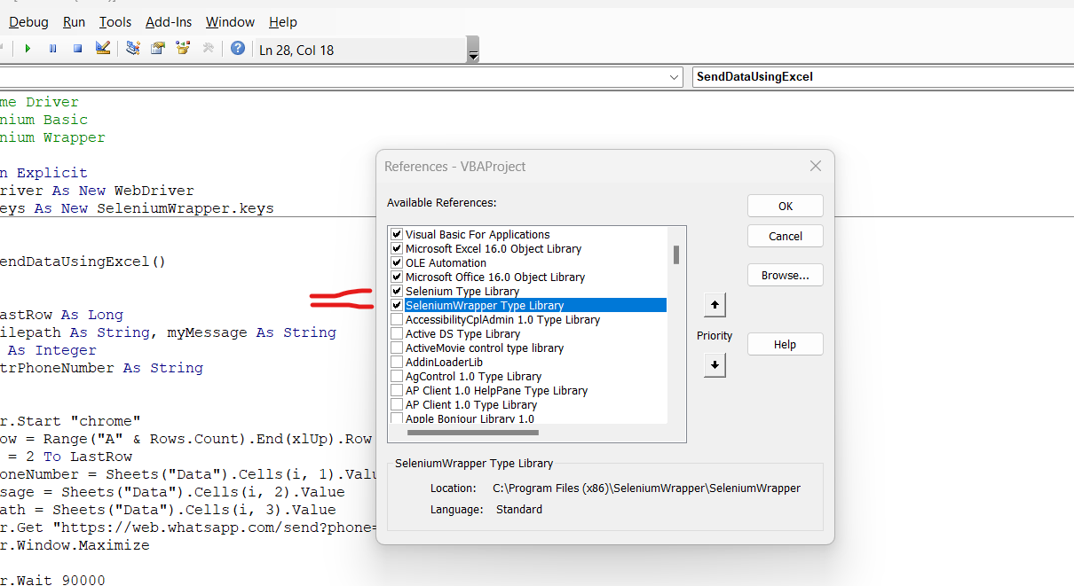
8. Then check the both selenium type library and seleniumwrapper type library
9. You can set your time according to your internet speed and processor .

e.g driver.Wait 90000 in vba module 1

1. Writing code process
2. Go to developer icon and click on visual basic and click on insert in vba .
3. Make new module paste VbaCode written in your folder .

In these lines change Data in to your Sheet name or change ur sheet name to Data

1. strPhoneNumber = Sheets("Data").Cells(i, 1).Value
2. myMessage = Sheets("Data").Cells(i, 2).Value
3. filepath = Sheets("Data").Cells(i, 3).Value

**For user :-🡪**

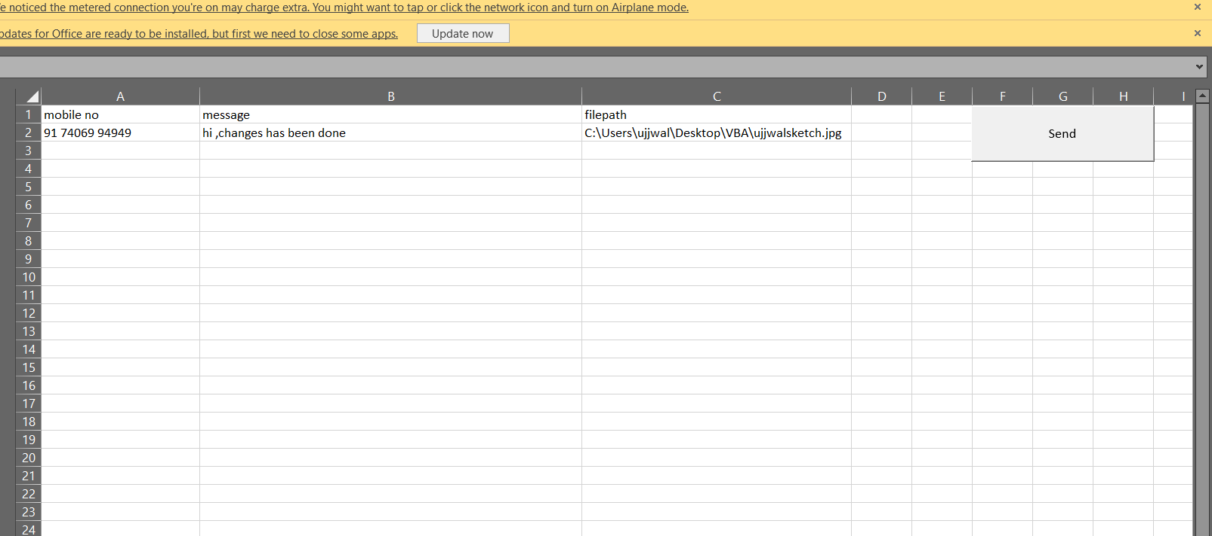

**Mobile no = should be with country code (“91”) only no more any character would be work properly**

**Message = contain messages**

**Filepath = path of your file which supports mp4,3gp,pdf,jpg**

**Send = is use to execute your programme .**